**How to install XDR Linux agent manualley:**

Download XDR agent from the console:

**Endpoints > Agent Installation**

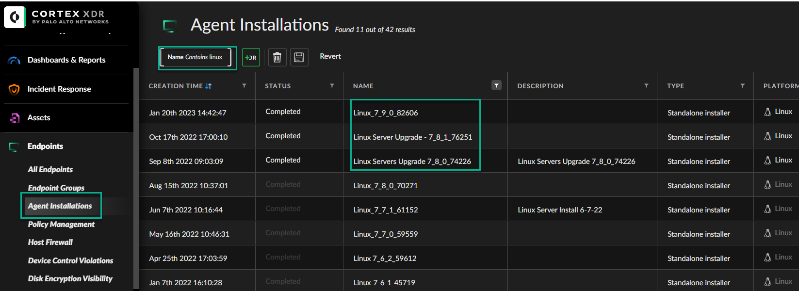

Select XDR agent > **Right click and downlod** the agent on to your system

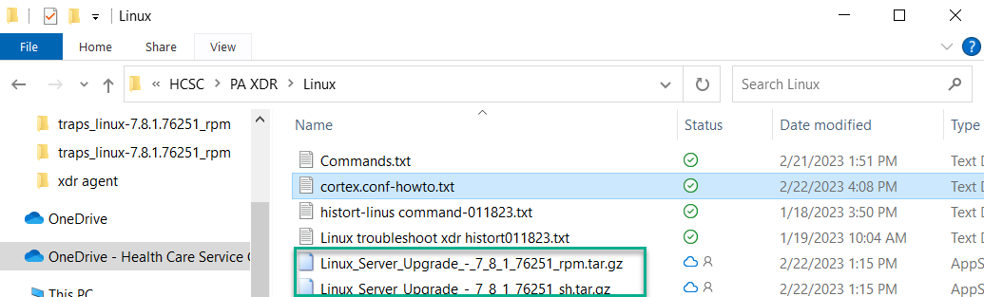

Copy downloaded *.tar.gz files on to Linux server (**might have to ask unix support team**) or use **WinSCP**

***Create **/home/XDR** folder and copied downloaded files (**folder name can be any name**)

Run command:

**tar zxvf** Linux_Server_Upgrade_-_7_8_1_76251_rpm.tar.gz -unzip file

**chmod u+x** cortex-7.8.1.76251.sh (file name) -give **permission to execute**

**Before installing the agent**, please copy `cortex.conf` into `/etc/panw/` directory.

**sudo mkdir -p /etc/panw**

**sudo cp ./cortex.conf /etc/panw/**

**sudo rpm -i** mypackage.rpm **(RPM package name) - if using RPM package (**look below screenshot**)**

**Login to XDR console > Endpoints and search the endpoint name, done.**

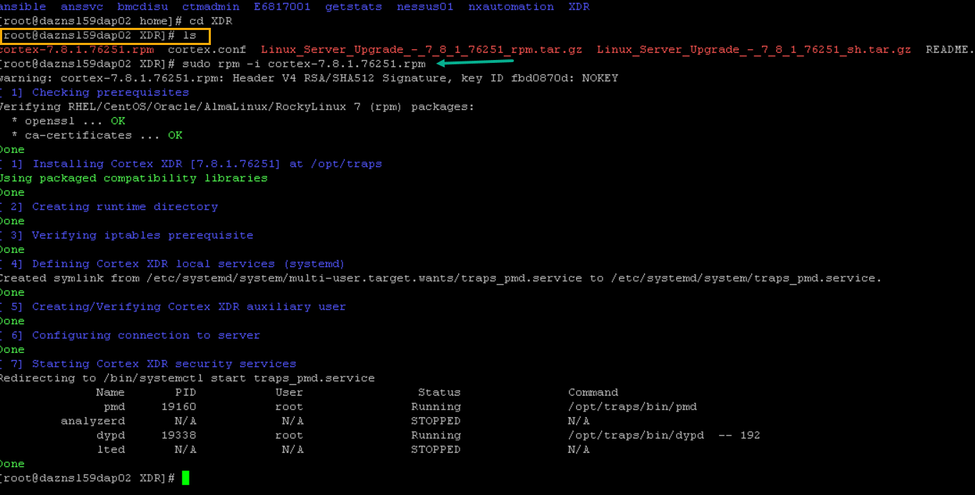

**\*\*If you want to remove or uninstall RPM packages from the system, then you can use the following terminal command**

**Manually remove RPM package**:

sudo rpm -e package name

**To uninstall using yum, the terminal command will be**

sudo yum remove package name